
Monday-Friday 8am-5pm

We Offer
- Learning Disorder/Disability Testing
- ADHD Testing
- Psychological Assessment
- Autism Testing

BASIC FEES
Learning Disorder Evaluation $400.00
ADHD Evaluation $75.00
Autism Evaluation $400.00

For questions or to be put on the wait list, please go to
https://www.uvu.edu/studenthealth/psych/ld-testing.html


Monday-Thursday 9am-3pm

We Offer
- Licensed Psychiatric Nurse Practitioner
- Psychiatric Assessment
- Psychiatric Medication Management

BASIC FEES
First Visit $30.00
Follow-Up Visit $15.00

For questions or to be put on the wait list, please email psychservices@uvu.edu.

FREE SERVICES
Therapy Groups
Consultation Services
Prescription Assistance
Medical Referrals
Crisis Visits

Utah Valley University
STUDENT HEALTH SERVICES

800 W. University Parkway
Orem, UT 84058
Second Level, Room SC-221

uvu.edu/studenthealth/
801-863-8876

GENERAL OFFICE HOURS
Monday-Thursday 8am-6pm
Friday 8am-5pm
Closed on Saturday & Sunday



STUDENT HEALTH SERVICES
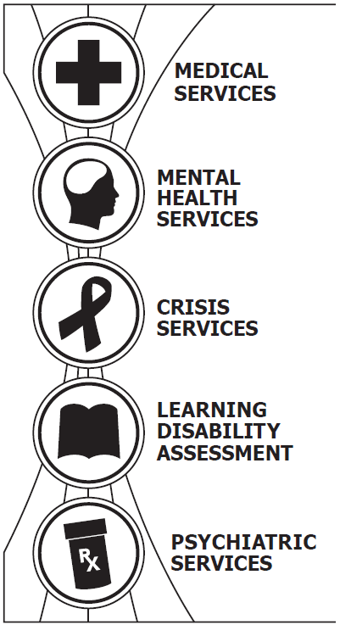


M/W/Th 9am-6pm, Tue/Fri 9am-5pm

We offer
- Certified Nurse Practitioners
- Certified Medical Assistants
- On-Campus Medical Facilities
- Full Services Laboratory Testing
- Immunizations
- Prescriptions

We help with
- Allergies
- Common Illnesses
- Minor Trauma & Injuries
- Contraception
- Women’s Health
- Anxiety & Depression
- Preventive Healthcare
- Basic Physicals

BASIC FEES
Basic Office Visit $15.00
Physical Exam $15.00-$50.00
Immunizations Varies
Lab Services Varies
TB Skin Test $10.00
Pregnancy Test $10.00

Fees and hours are subject to change without notice. A No-Show Fee of $10-$20 will be charged without 24-hour prior cancellation of appointment. All services are available to students currently enrolled at Utah Valley University. Insurance is not required, nor is it an accepted form of payment.


Monday-Friday 8am-5pm

We offer
- Licensed Psychologists
- Licensed Mental Health Counselors
- Various Therapy Groups
- Preventive Outreach Programs

We help with
- Depression
- Trauma & Bereavement
- PTSD
- Eating Disorders
- Anxiety
- Stress Management
- Addictions
- Abuse
- Couples Counseling
- Relationship Issues

BASIC FEES
Full Therapy Session $10.00
30-Min. Therapy Session $5.00
Couples Counseling Session $10.00
Group Therapy FREE

Eligibility
Fall and Spring semesters - 9+ credits
Summer semester - 6+ credits


Monday-Friday 8am-4:15pm

WE OFFER
- Licensed Clinical Social Worker
- Certified Suicide Prevention Instructor
- Suicide Prevention Training

WE OFFER FREE HELP WITH
- Crisis Assessment & Collaboration
- Crisis Intervention & Referral

EMERGENCY RESOURCES
- Suicide and Crisis Lifeline: 988
24-Hour Service
- Emergency Telephone: 911
- UVU Campus Police:
801-863-5555
- Student Health Services:
801-863-8876
(Indicate that you have an emergency)
- Go to your local Hospital Emergency Room

